**Welcome To Asset Management System**

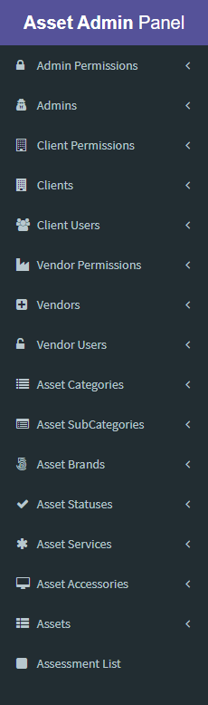**Options / Menu Lists:** There are lots of menu in asset management admin panel. These are:

1. Admin Permissions (Permissions Category)
2. Admins
3. Client Permissions (Permissions Category)
4. Clients
5. Clients Users
6. Vendor Permissions (Permissions Category)
7. Vendors
8. Vendor Users
9. Asset Categories
10. Asset Sub Categories
11. Asset Brands
12. Asset Statuses
13. Asset Services
14. Asset Accessories
15. Assets
16. Assessment List

**Lets we discuss about above option step by step…**

**.**

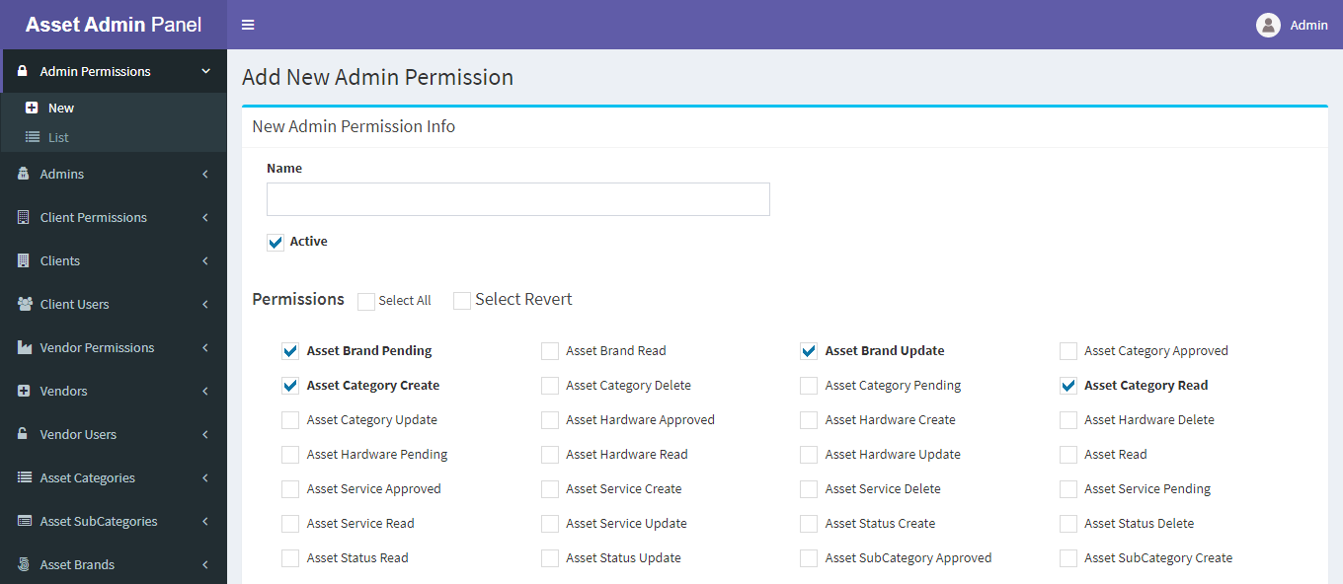**1. Admin Permissions (Permissions Category): This option helps you to create different type of permission categories to assign custom permission role to a specific admin user.**

* To create an admin permission go to Admin Permissions => New
* From the above option input the permission name and check which permissions attach in this permission category. Then submit
* 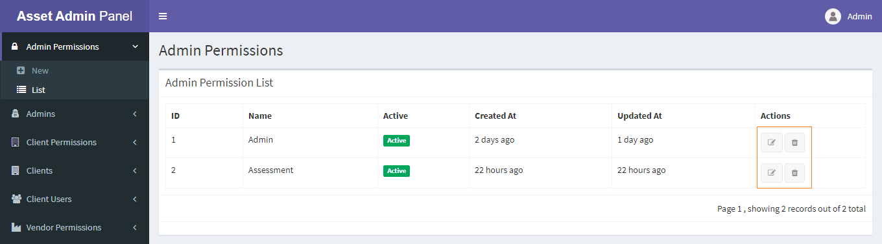After successfully created a permission category you can see your newly created permission category from the List dropdown menu under Admin Permissions.
* From the above list you can see your all lists.
* Important note is that when you create an admin user and assign custom role then you can see only that permission which are created in this category. So at first create all permission category the create admin user.
* Remember that if anyone permission which is assign to a user that’s under in the above category list then you can’t remove or edit that specific category.

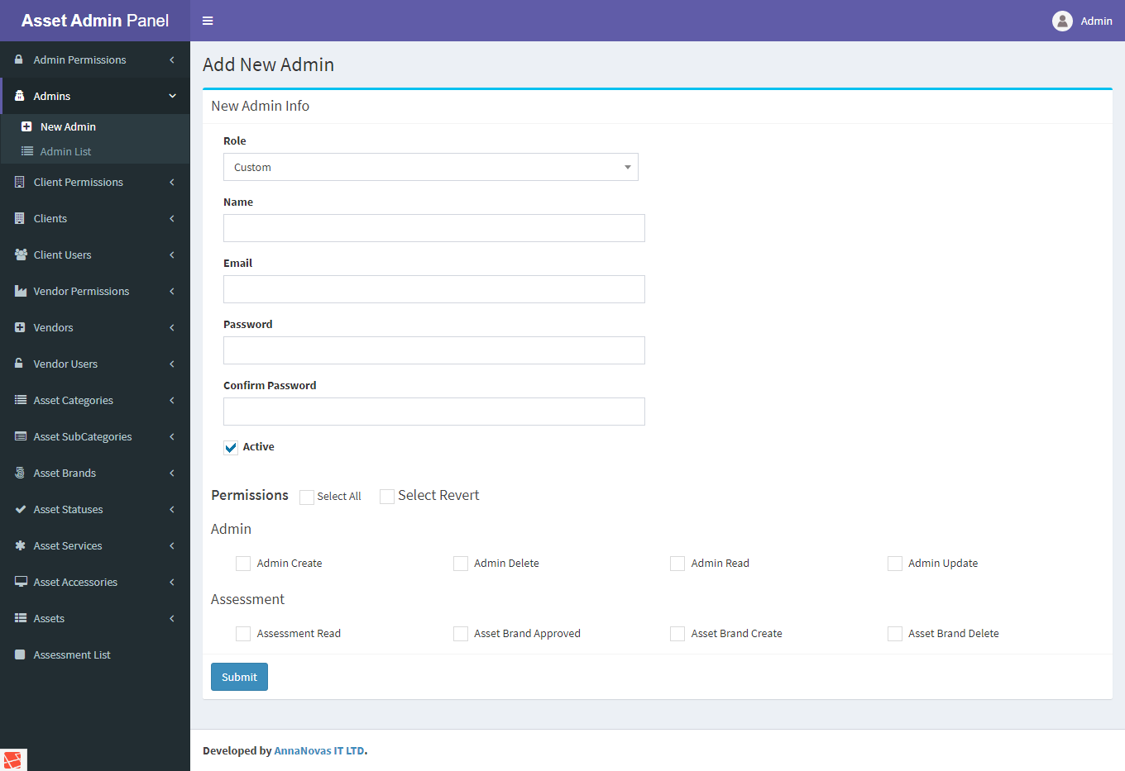**2. Admins: Admins menu is responsible for creating new Admin users in your requirement.**

* To create a new Admin user please navigate to Admins => New Admin
* At first select your admin role. There are basically built in two kinds of role 1st **Admin** and 2nd **Custom** role.
* If you select **Admin** role then you can’t see any permission category list.
* But if you select **Custom** role then you can see your all created permission category list in the bellow then select you’re permissions which want to assign to this admin user.
* After successfully created a user you can see your newly created admin user from the Admin List dropdown menu under Admins.
* 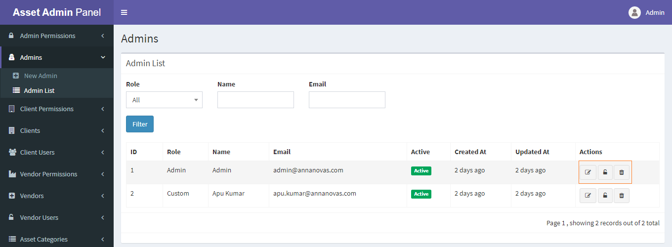From the Admin List you can edit or delete your user. You can also reset password by clicking lock icon.

**3. Client Permissions: Client Permissions menu is responsible for creating all client permissions category.**

* 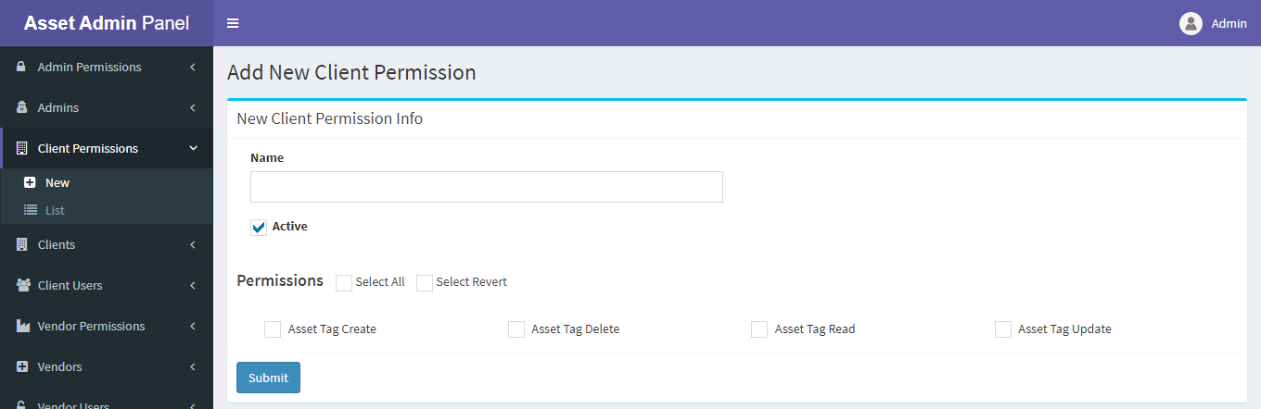To create a new client permission category please navigate to Client Permissions => New
* You can see all permissions which are not enlisted any category.
* Then you input your permission category name and checked permission and submit.
* 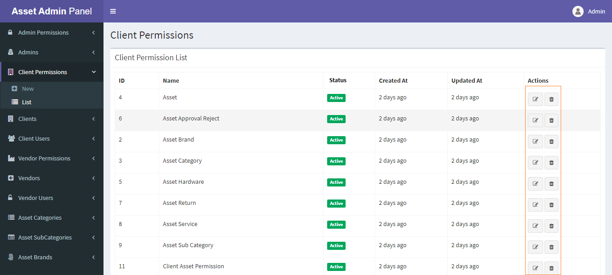After successfully created a permission category you can see your newly created permission category from the List dropdown menu under Client Permissions.
* From Client Permissions List you can edit or delete the permission category. If you delete any category then remove all permissions associate with this category.
* Remember Client can only see that permission which you made in category list. So create all permission categories which you want to assign to the client.

**4. Clients: Clients menu is responsible for creating a new client and viewing all clients.**

* 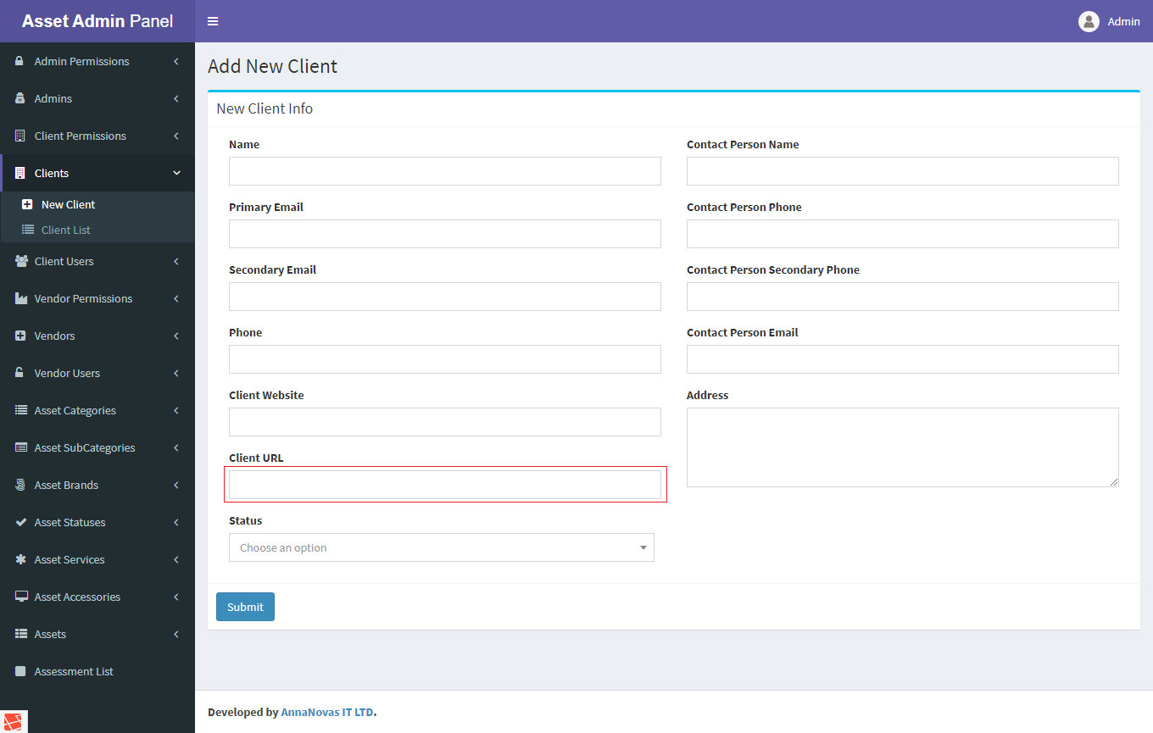To create a new client please navigate to Clients => New Client
* From the above form fill up all client information. The important field is the **client url** please input the exact unique url for this client.
* 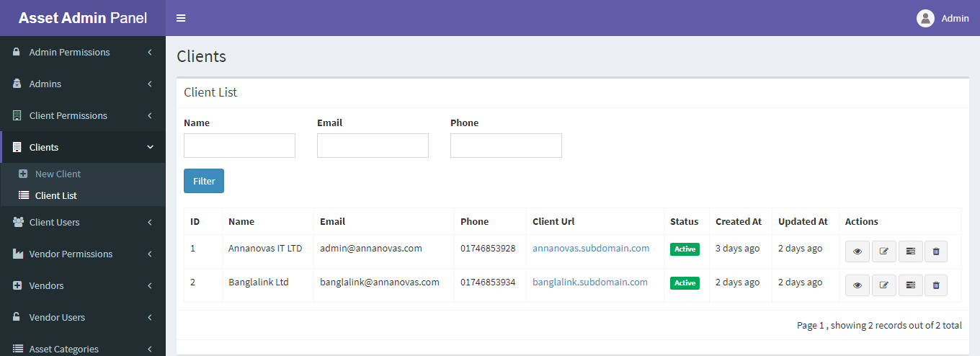After successfully created a client you can see your newly created client from the Client List dropdown menu under Clients.
* From the above list you can see all client lists.
* You can edit delete as well as create new role for this client.

**5. Client Users: Client Users menu is responsible for creating a new client user and viewing all client users.**

* 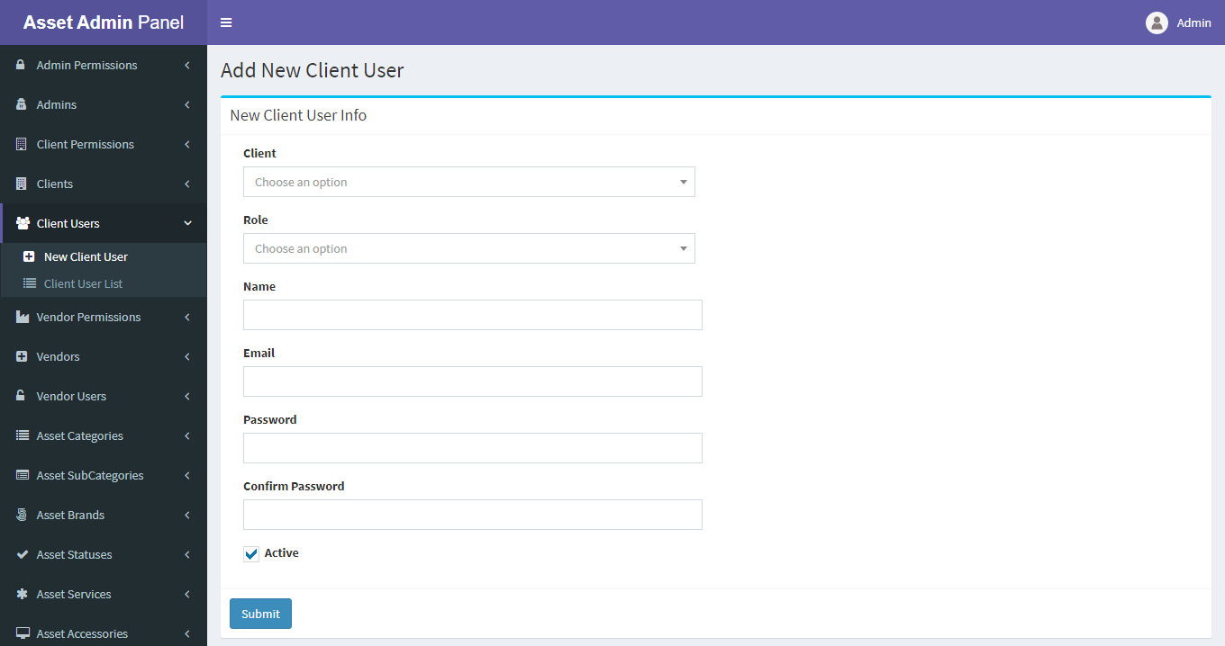To create a new client user please navigate to Client Users => New Client User
* From the above form, at first select any client then automatically show all roles associate with this client.
* 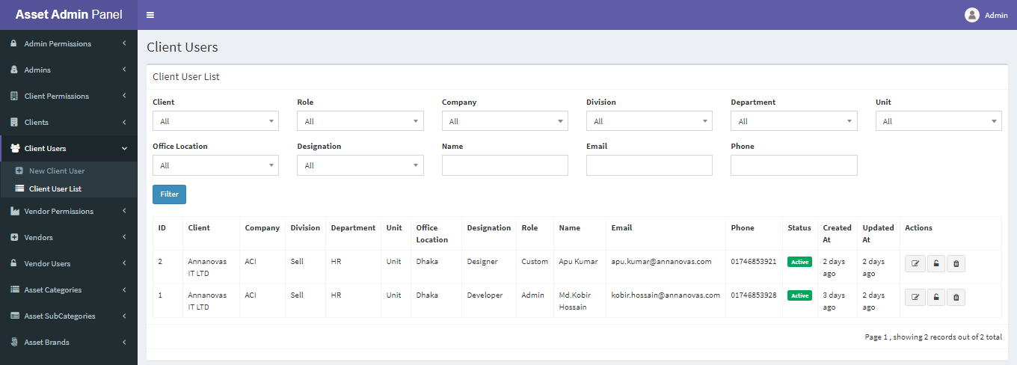After successfully create a client user you can see your users from the Client User List dropdown under Client Users menu.
* From the above list you can edit / delete or reset password of any client user.

**6. Vendor Permissions: Vendor Permissions menu is responsible for creating all vendor permissions category.**

* 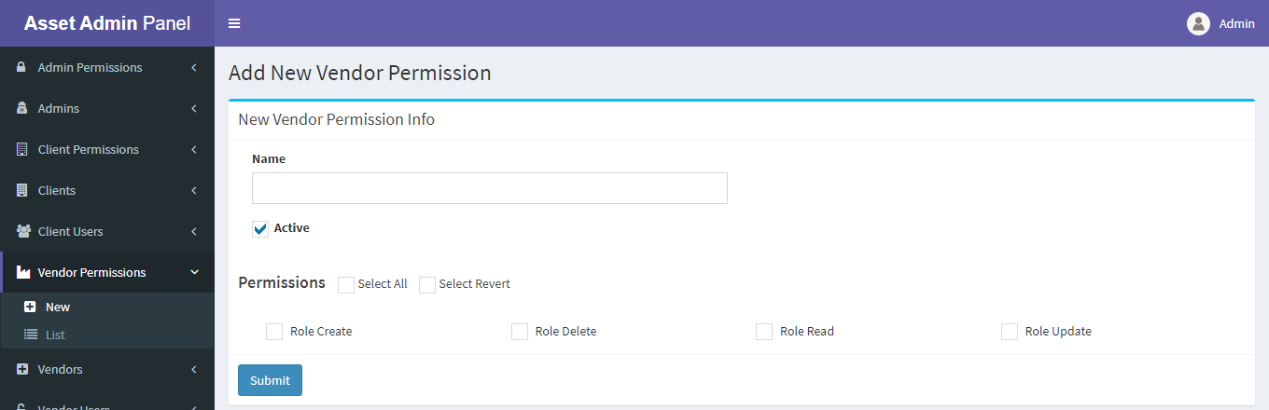To create a new vendor permission category please navigate to Vendor Permissions => New
* You can see all permissions which are not enlisted any category.
* Then you input your permission category name and checked permission and submit.
* After successfully created a permission category you can see your newly created permission category from the List dropdown menu under Vendor Permissions.
* From Vendor Permissions List you can edit or delete the permission category. If you delete any category then remove all permissions associate with this category.
* 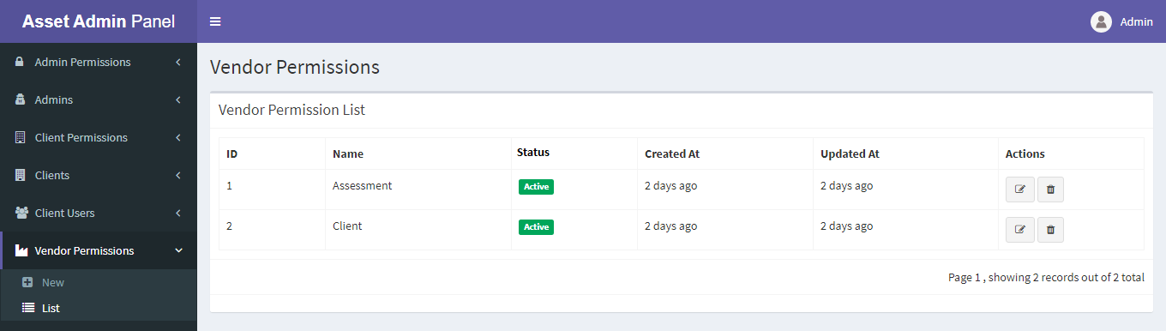Remember Vendor can only see that permission which you made in category list. So create all permission categories which you want to assign to the vendor.

**7. Vendors: Vendors menu is responsible for creating a new vendor and viewing all vendors.**

* 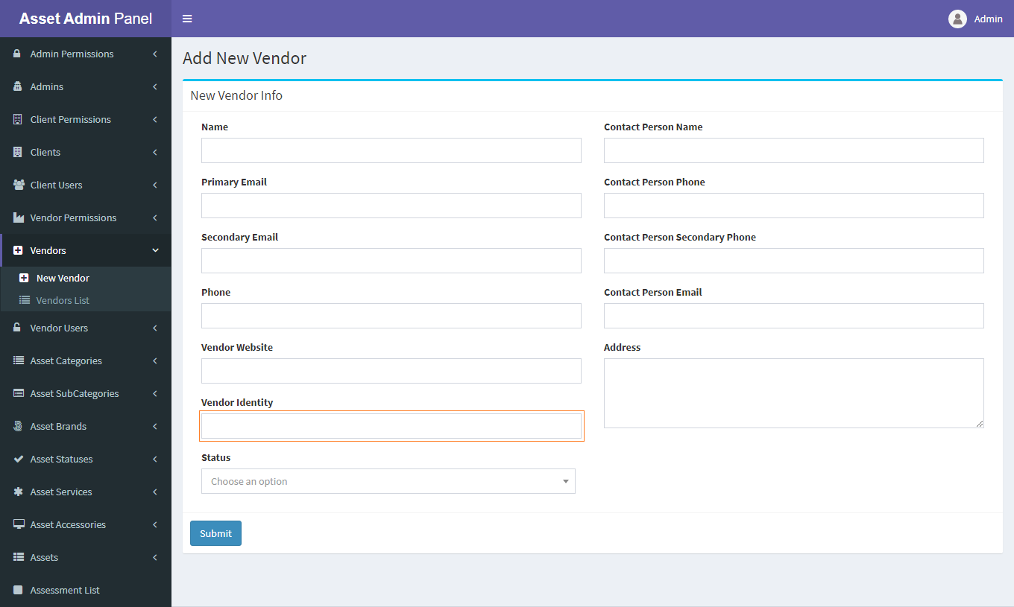To create a new vendor please navigate to Vendors => New Vendor
* From the above form fill up all vendor information. The important field is the **vendor Identity** please input the exact unique **vendor Identity** for this vendor.
* After successfully created a vendor you can see your newly created vendor from the Vendor List dropdown menu under Vendors.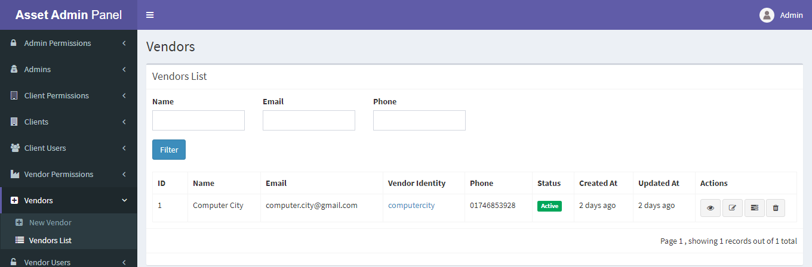
* From the above list you can see all vendor lists.
* You can edit delete as well as create new role for this vendor.

**8. Vendor Users: Vendor Users menu is responsible for creating a new vendor user and viewing all vendor users.**

* 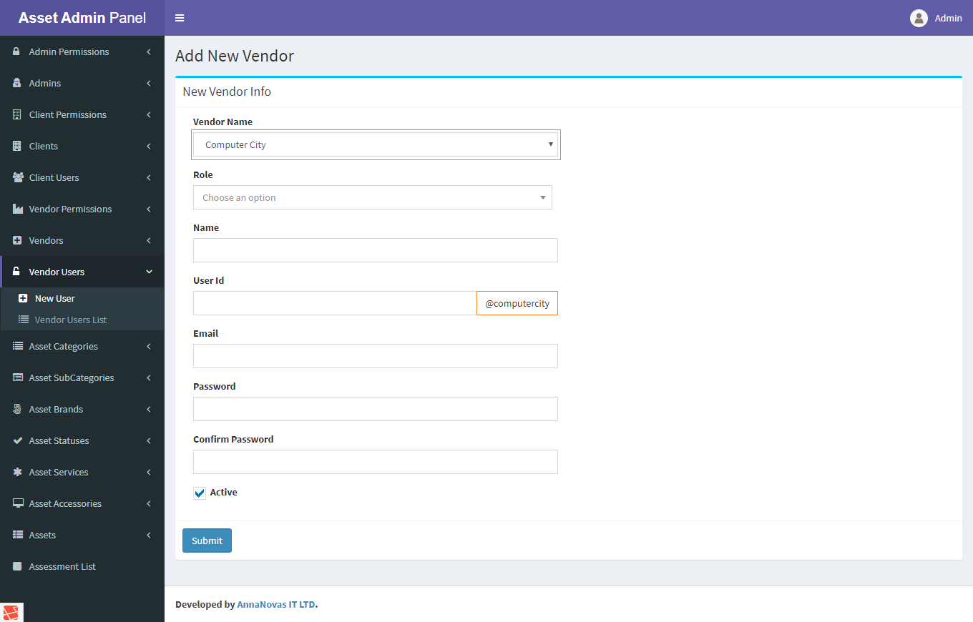To create a new vendor user please navigate to Vendor Users => New Vendor User
* From the above form, first select any vendor then automatically show all roles associate with this vendor.
* 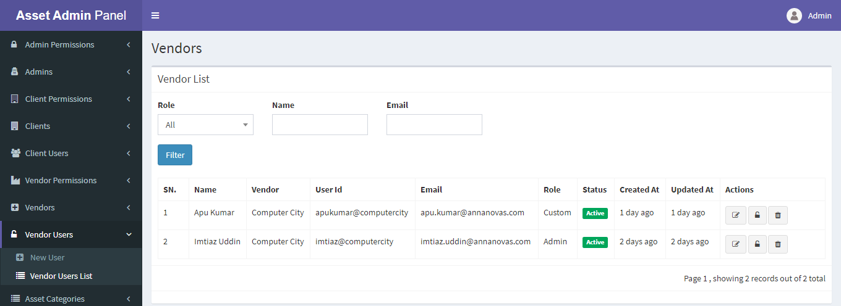After successfully create a vendor user you can see your users from the Vendor User List dropdown under Vendor Users menu.
* From the above list you can edit / delete or reset password of any vendor user.

**9. Asset Categories: Asset Categories menu is responsible for creating a new category and viewing all categories.**

* 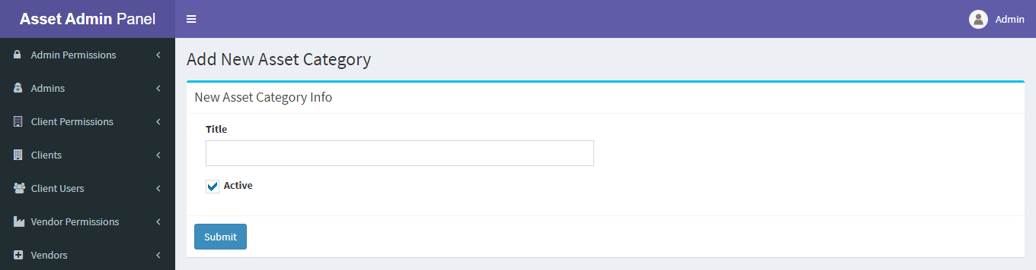To create a new category please navigate to Asset Categories => New Category
* After successfully create a category you can see your newly created category from Category List.
* 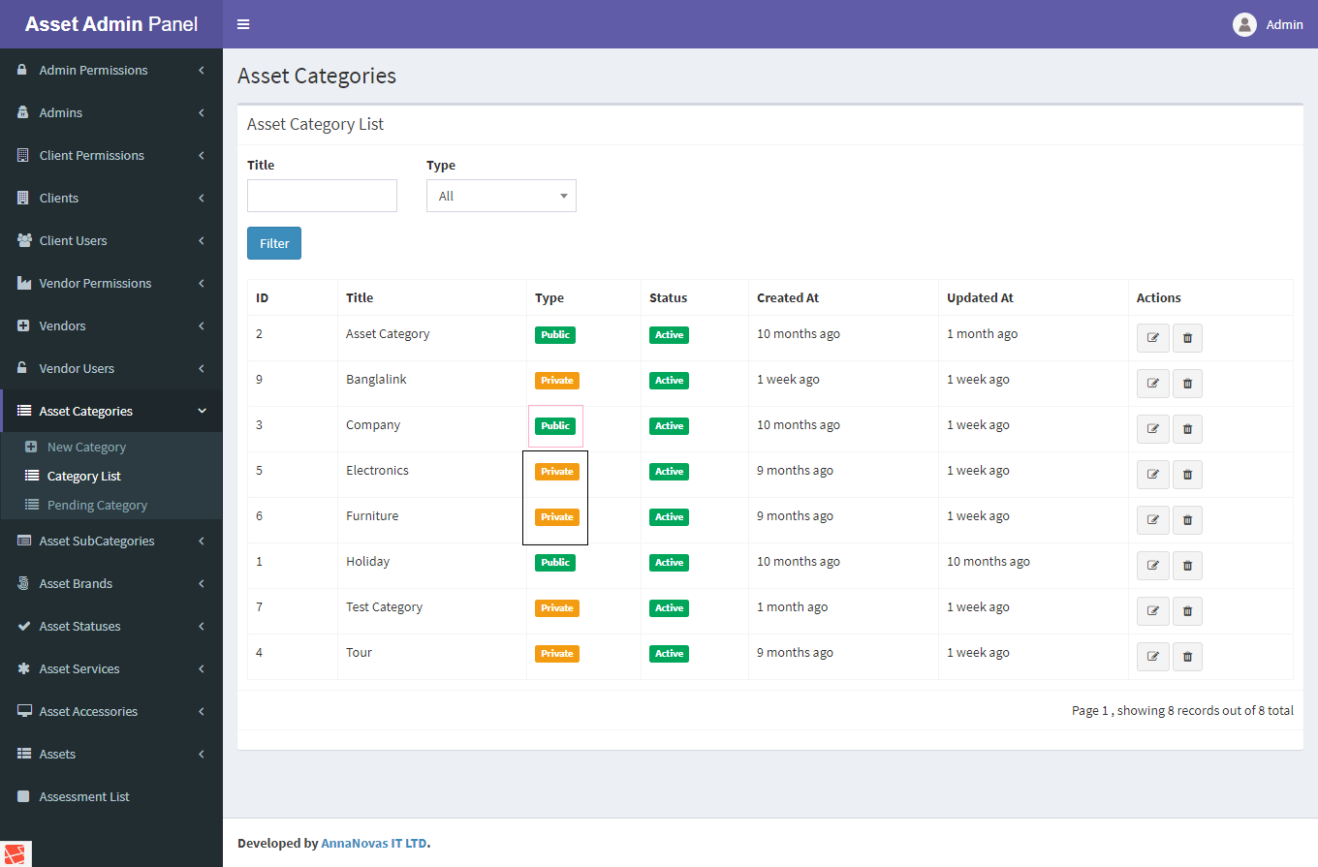From the Category List you can see there are two types **public** and **private.**
* By default when you create a category, type will be **public** that mean all client can use this category.
* 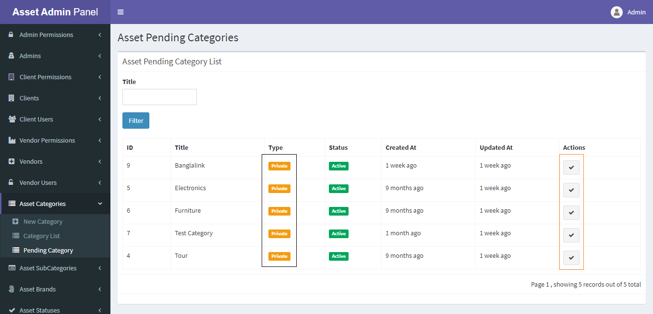The other **private** type of category. When any client create a category this category will be private and you can also see that categories. You can edit **private** type category to public from Pending Category list.
* If any **private** type category you approved as **public** then the original owner (client) of that category can’t edit or delete anymore.
* You can edit or delete any type of category.

**10. Asset Sub Categories: Asset Sub Categories menu is responsible for creating a new sub category and viewing all sub categories.**

* 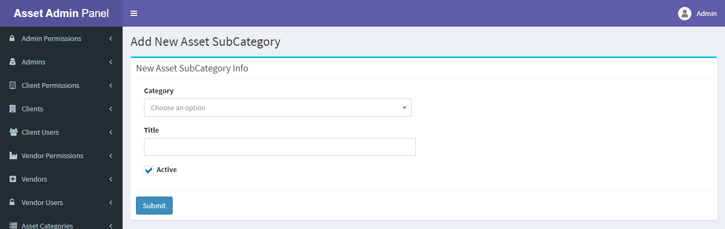To create a new sub category please navigate to Asset Sub Categories => New Sub Category
* 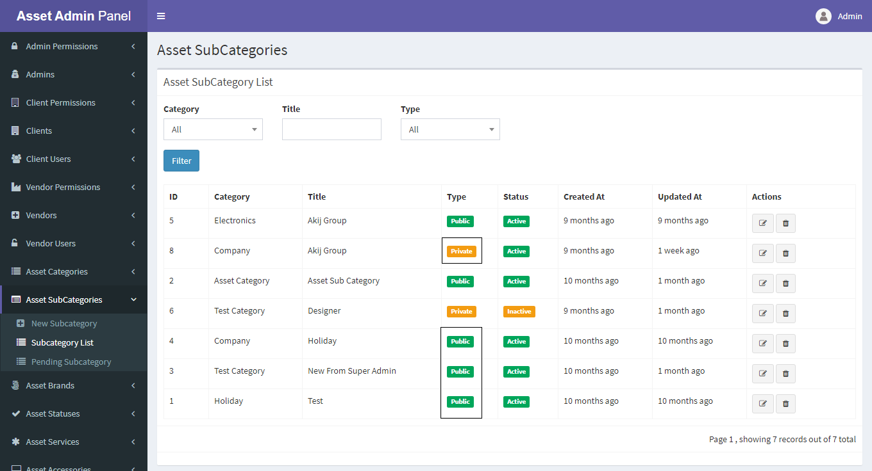After successfully create a sub category you can see your newly created sub category from Sub Category List.
* From the Sub Category List you can see there are two types **public** and **private.**
* By default when you create a sub category type will be **public** that mean all client can use this sub category.
* 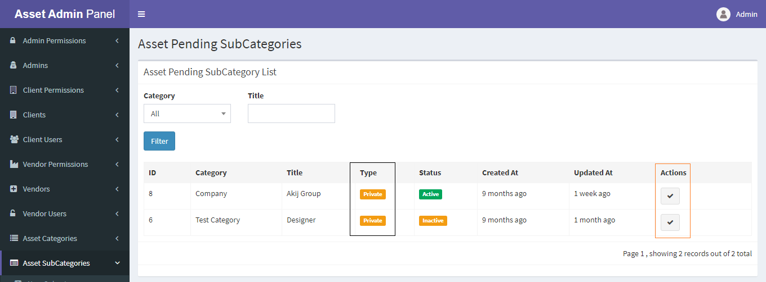The other **private** type of sub category. When any client create a sub category this sub category will be private and you can also see that sub categories. You can edit private type sub category to public from Pending Sub Category list.
* If any **private** type sub category you approved as **public** then the original owner (client) of that sub category can’t edit or delete anymore.
* You can edit or delete any type of sub category.

**11. Asset Brands: Asset Brands menu is responsible for creating a new brand and viewing all brands.**

* 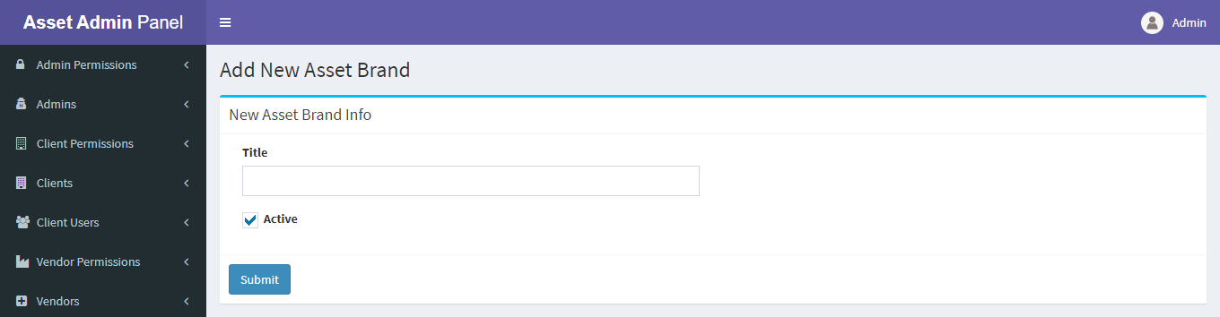To create a new brand please navigate to Asset Brands => New Brand
* 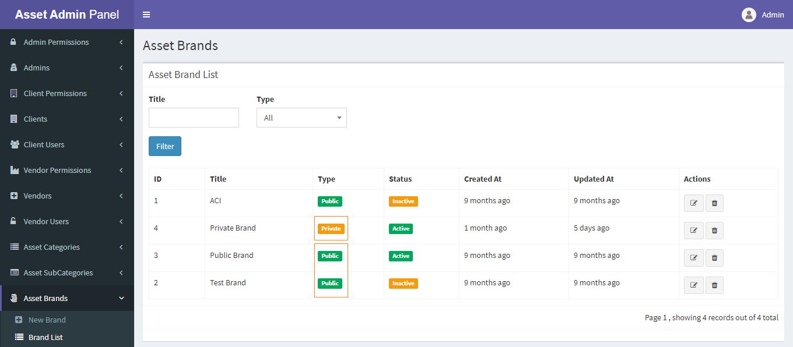After successfully create a brand you can see in your newly created brand from Brand List.
* From the Brand List you can see there are two types **public** and **private.**
* By default when you create a brand, type will be **public** that mean all client can use this brand.
* The other **private** type of brand. When any client creates a brand then this brand will be private and you can also see that brand. You can edit private type brand to public from Pending Brand list.
* 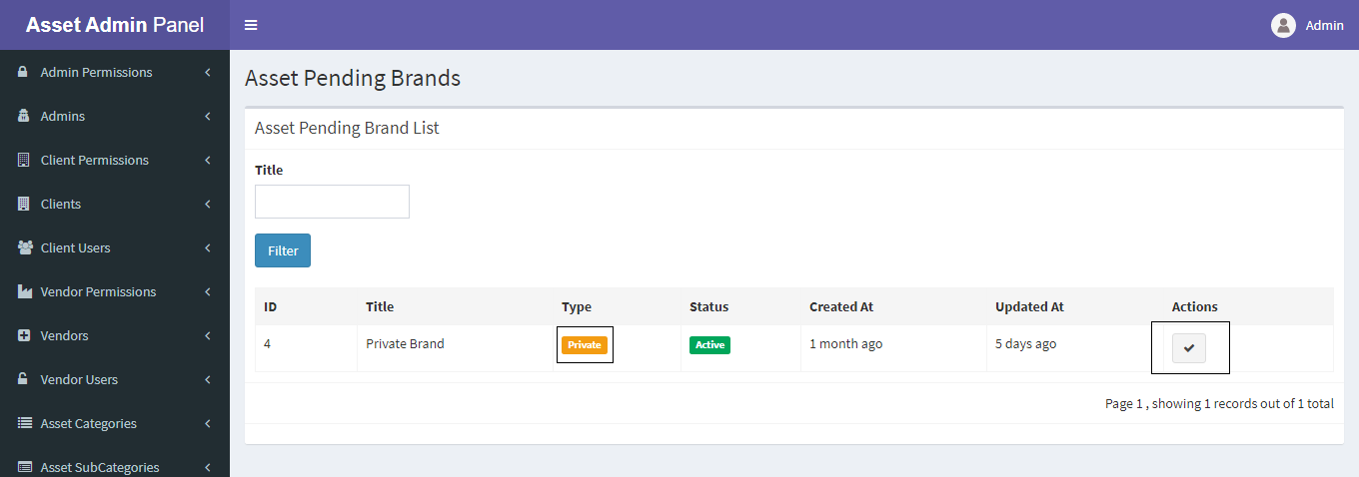If any **private** type brand you approved as **public** then the original owner (client) of that brand can’t edit or delete anymore.
* You can edit or delete any type of brand.

**12. Asset Statuses: Asset Statuses menu is responsible for creating a new status and viewing all statuses.**

* 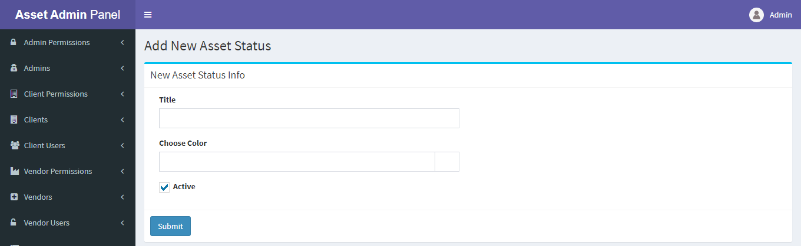To create a new status please navigate to Asset Statuses => New Status
* 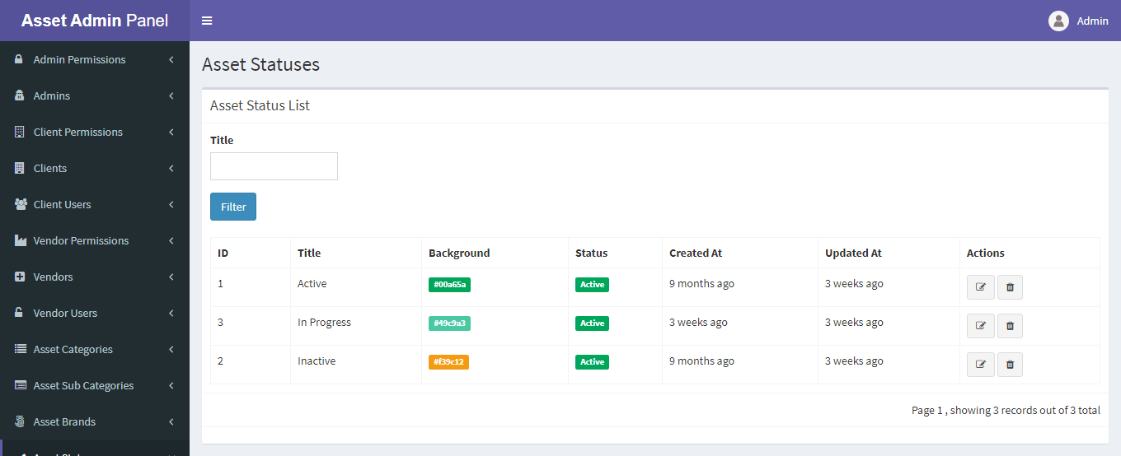After successfully create a status you can see in your newly created status from Status List.
* From the Status List you can edit or delete any status**.**

**13. Asset Services: Asset Services menu is responsible for creating a new service and viewing all services.**

* 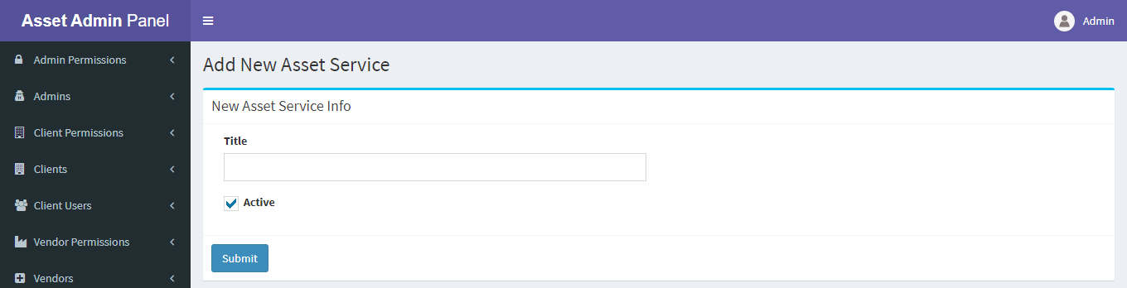To create a new service please navigate to Asset Services => New Service
* 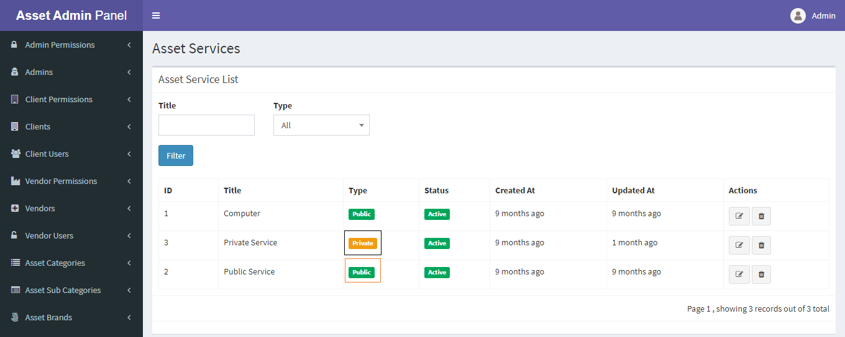After successfully create a service you can see in your newly created service from Service List.
* From the Service List you can see there are two types **public** and **private.**
* By default when you create a service, type will be **public** that mean all client can use this service.
* 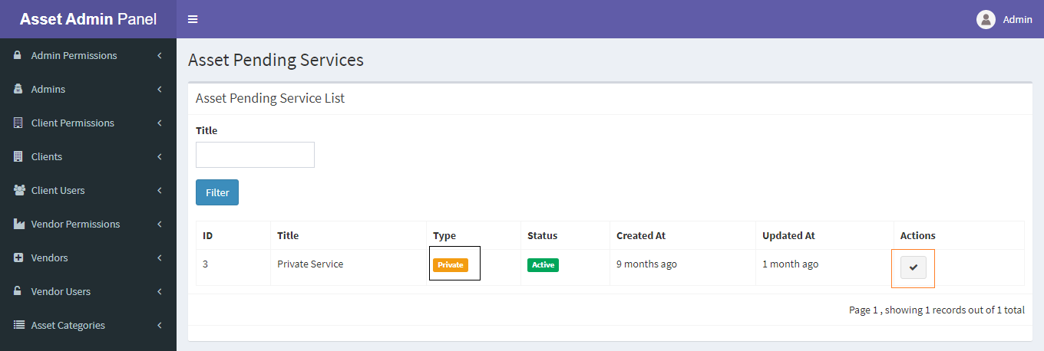The other **private** type of service. When any client creates a service then this service will be private and you can also see that service. You can edit private type service to public from Pending Service list.
* If any **private** type service you approved as **public** then the original owner (client) of that service can’t edit or delete anymore.
* You can edit or delete any type of service.

**14. Asset Accessories: Asset Accessories menu is responsible for creating a new accessory and viewing all accessories.**

* 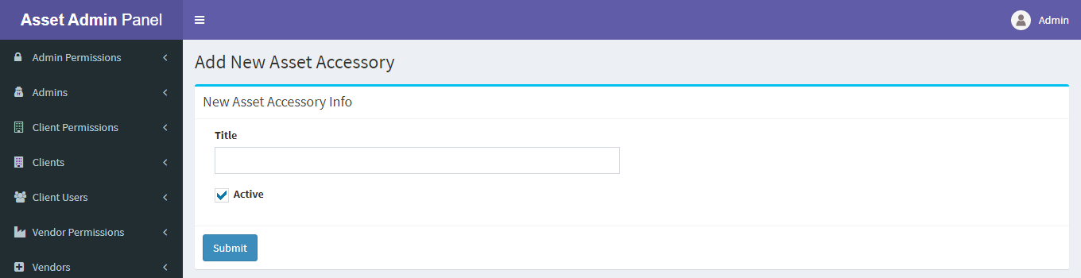To create a new accessory please navigate to Asset Accessories => New Accessory
* 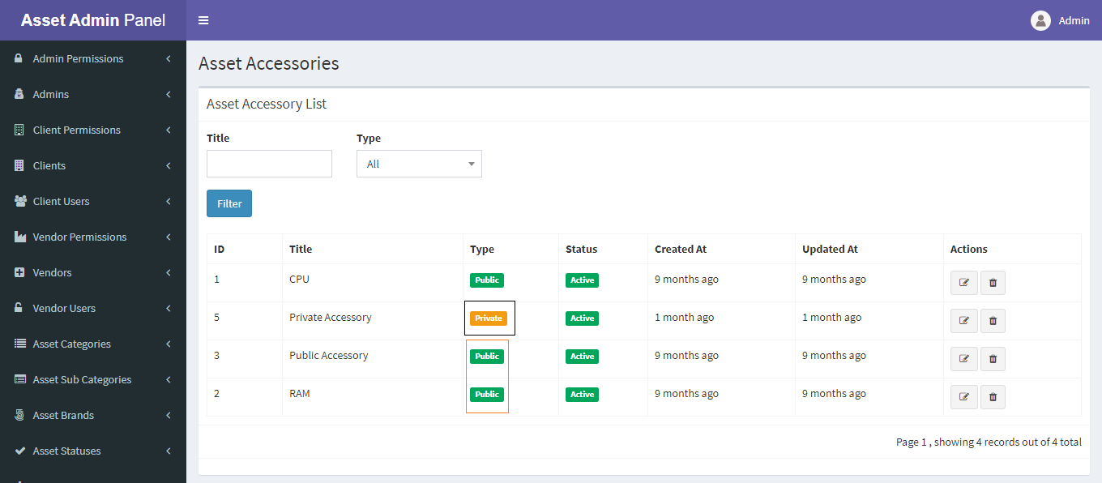After successfully create an accessory you can see in your newly created accessory from Accessory List.
* From the Accessory List you can see there are two types **public** and **private.**
* By default when you create an accessory, type will be **public** that mean all client can use this accessory.
* The other **private** type of accessory. When any client creates an accessory then this accessory will be private and you can also see that accessory. You can edit private type accessory to public from Pending Accessory list.
* 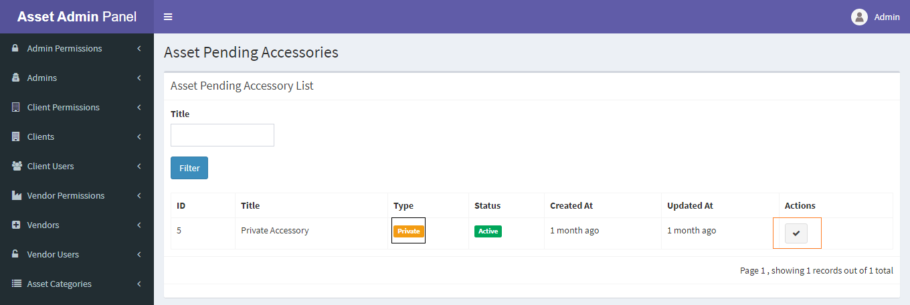If any **private** type accessory you approved as public then the original owner (client) of that accessory can’t edit or delete anymore.
* You can edit or delete any type of accessory.

**15. Assets: Assets menu is responsible for viewing all assets either active or archive list.**

* 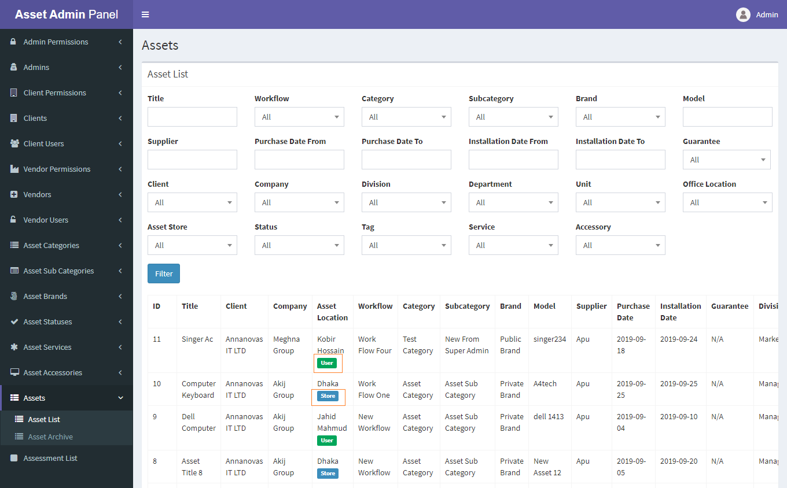From Asset List you can view all client assets which are not in archive.
* From Asset Archive you can view all client assets which are in archive.
* From both list you can only details of that specific asset.

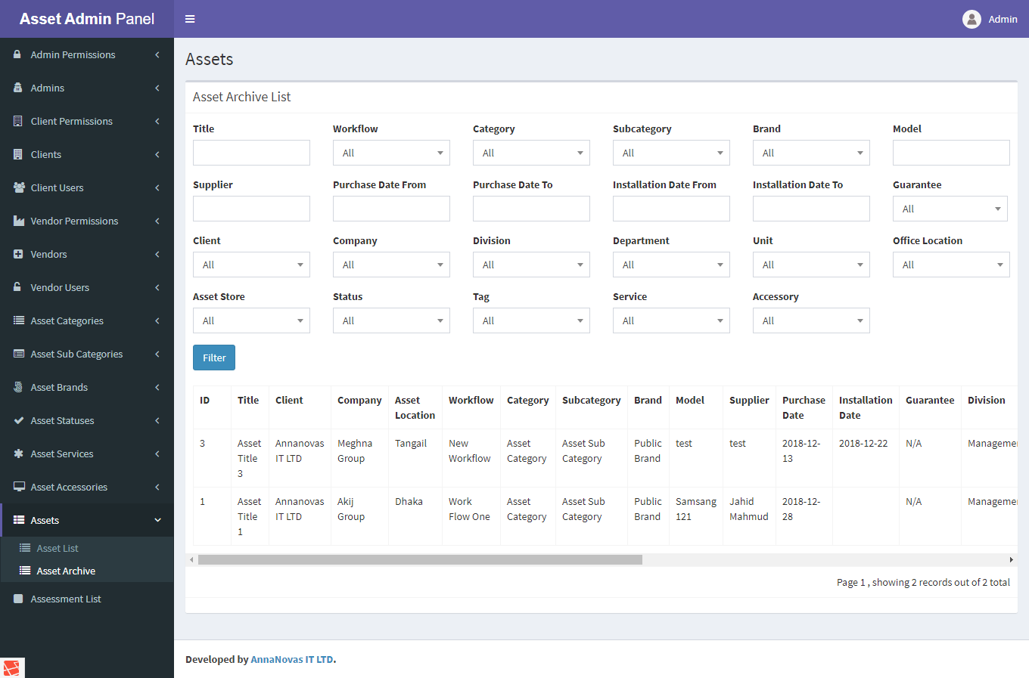**16. Assessments: Assessments menu is responsible for viewing all assessments list. Assessment mean which assets already been repaired.**

* To view which assets are repaired then click Assessments List.
* You can also view current assessment status.

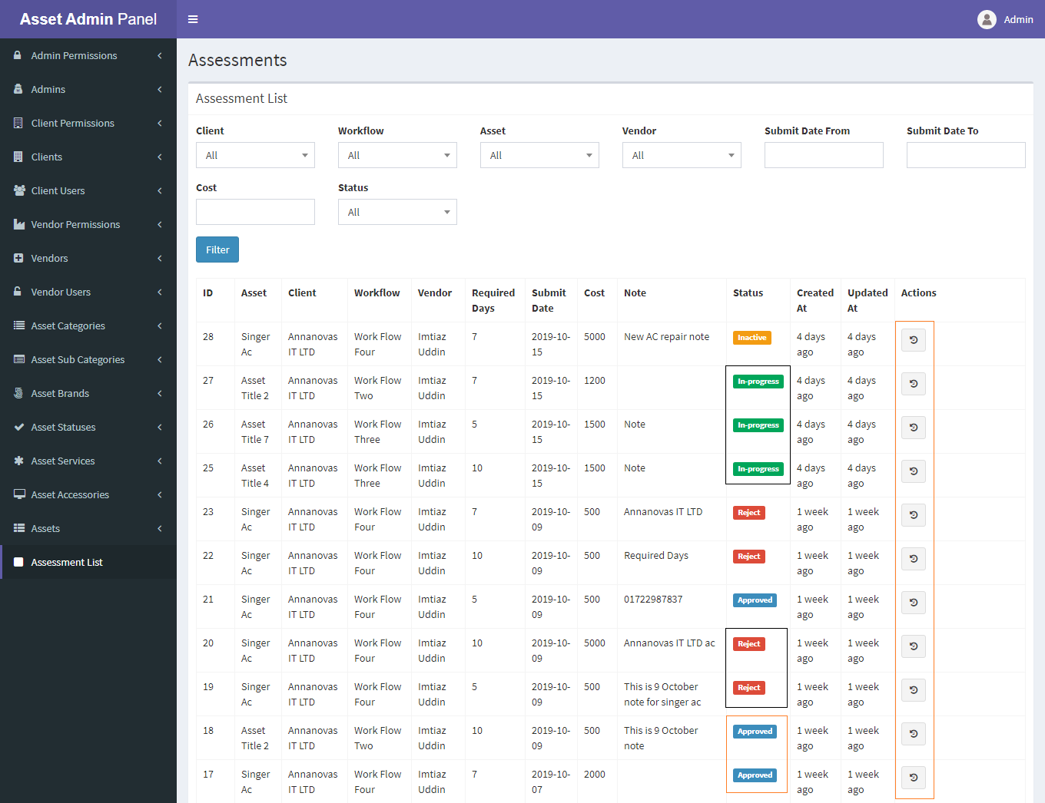

* By clicking action icon then you can view timeline of that specific asset.

